Round Table Card Game: Type in your questions or cue words in boxes
Copyright © 2009 www.eslgamesworld.com Designed by Futonge Kisito

Copyright © 2009 www.eslgamesworld.com Designed by Futonge Kisito

Copyright © 2009 www.eslgamesworld.com Designed by Futonge Kisito

Copyright © 2009 www.eslgamesworld.com Designed by Futonge Kisito

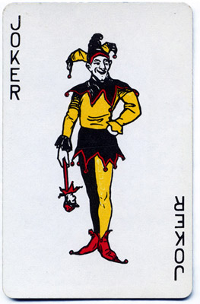

Copyright © 2009 www.eslgamesworld.com Designed by Futonge Kisito

Round Table Card Game
Points System

- 2 – 10 = Points according to number on card
- J= 12 pts
- K= 15pts
- Q= 15 pts
- A = 20 pts
- Joker = All your Cards x2

Copyright © 2009 www.eslgamesworld.com Designed by Futonge Kisito

How to Play:
Type in questions, sentences or cue words you want to practice into the boxes below each card. Cut out the cards and laminate them if you plan to reuse. (If you are running out of planning time, another idea would be to cut out the cards with the blanks-do not laminate- take them to class and ask students to write words on them and give you back. You collect all cards, shuffle the cards and place them face down to begin the game.)
Shuffle the cards and put them face down. In class students sit around the table with cards and take turns drawing cards. If you chose to write cue words on the card for example, ask the student with the cue card to describe the word on the card. The first student to guess the word gets the card. If it is a question, the first student to give the answer gets the card. Students keep collecting cards as they answer questions.
At the end, students count their points according to the numbers on the cards. For example if you have a card with the number 2, you have 2 points. If your card has a 10, you have 10 points and so on.
Then the J= 12 pts , K= 15pts Q= 15 pts , A = 20 pts then a Joker = Doubles the points on all the cards you have. It would be a good idea to make the questions from J to Joker more difficult.
Copyright © 2009 www.eslgamesworld.com Designed by Futonge Kisito

